**Stage 1 - Royale with cheese**

**RULES:** USPSA Competition Rules, Latest Edition **COURSE DESIGNER:** Ryan Christenson

|  |  |
| --- | --- |
| **START POSITION:** See WSB | |
| **STAGE PROCEDURE**  See written stage briefing. | **SCORING**  **SCORING:** Comstock 28 rounds.  **TARGETS:** 14 cardboard targets  **SCORED HITS:** 2 Best hits per carboard will be scored. Steel must fall to score.  **START-STOP:**  Audible - Last shot  **PENALTIES:** Per USPSA Competition Rules |

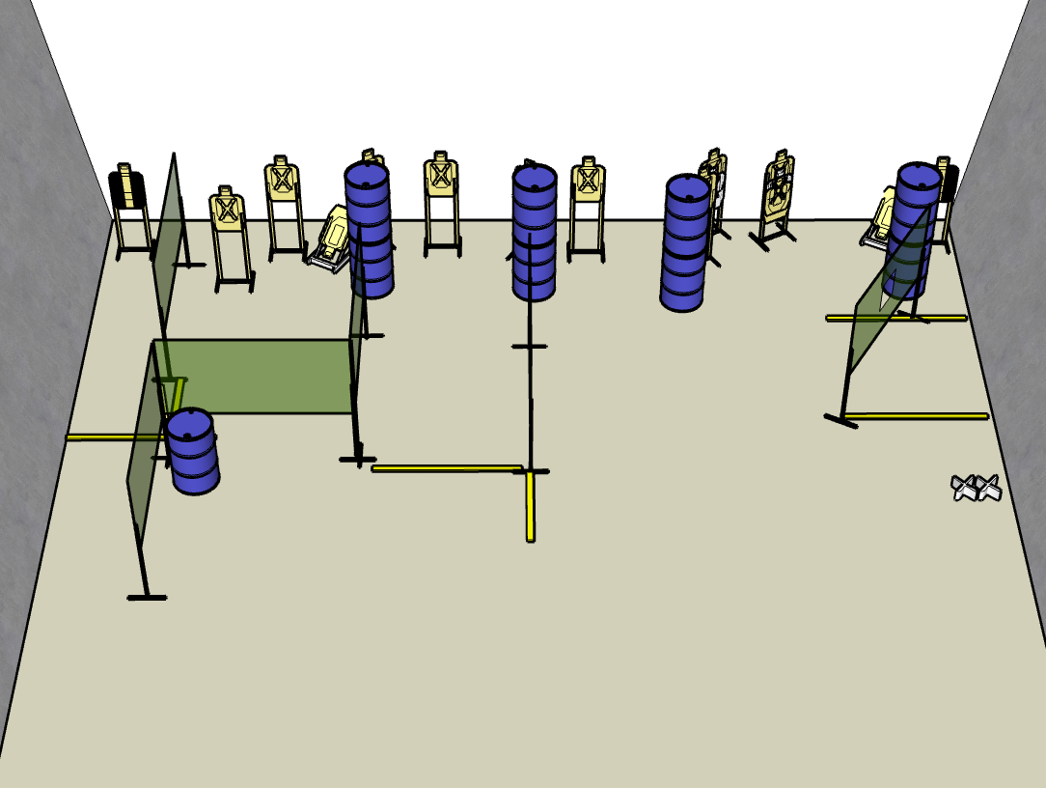

**Written Stage Briefing:**

**Stage 1 - Royale with cheese -** is a 28-round, 140 point, Comstock Long Course. There are 14 cardboard targets. The best 2 hits per cardboard target will be scored.

**Start position** Both feet on Xs

**Handgun**: Loaded and holstered, wrists below belt.

**PCC**: Loaded, held in both hands, buttstock touching belt.

On the audible start signal, engage targets from within the shooting area.

**USPSA / NROI Range Commands:**

* Make Ready
* Are you ready?
* Standby
* If finished, unload and show clear.
* If clear, hammer down and holster
* Range is clear